13.DECISION TREE

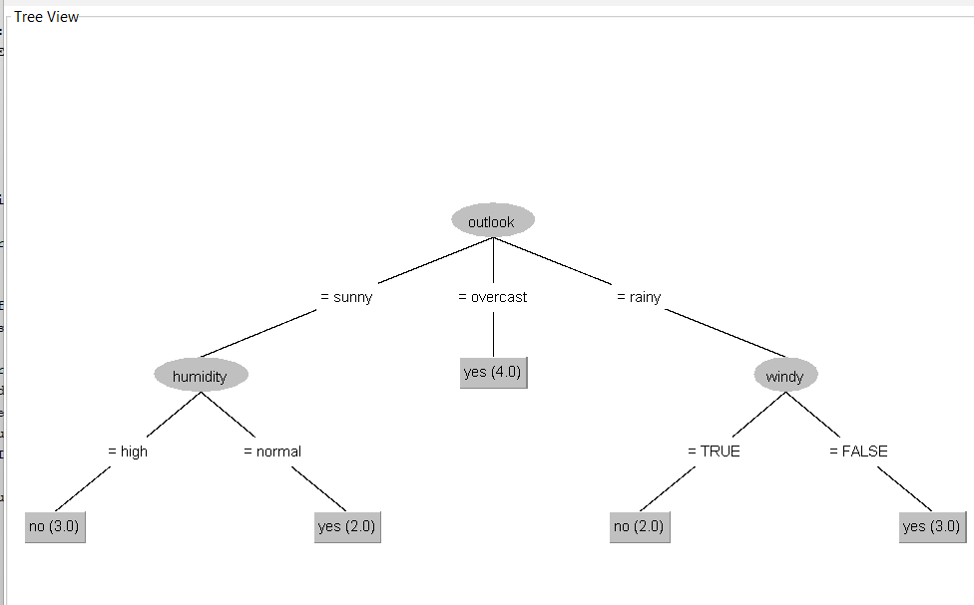

TREE VISUALISATION

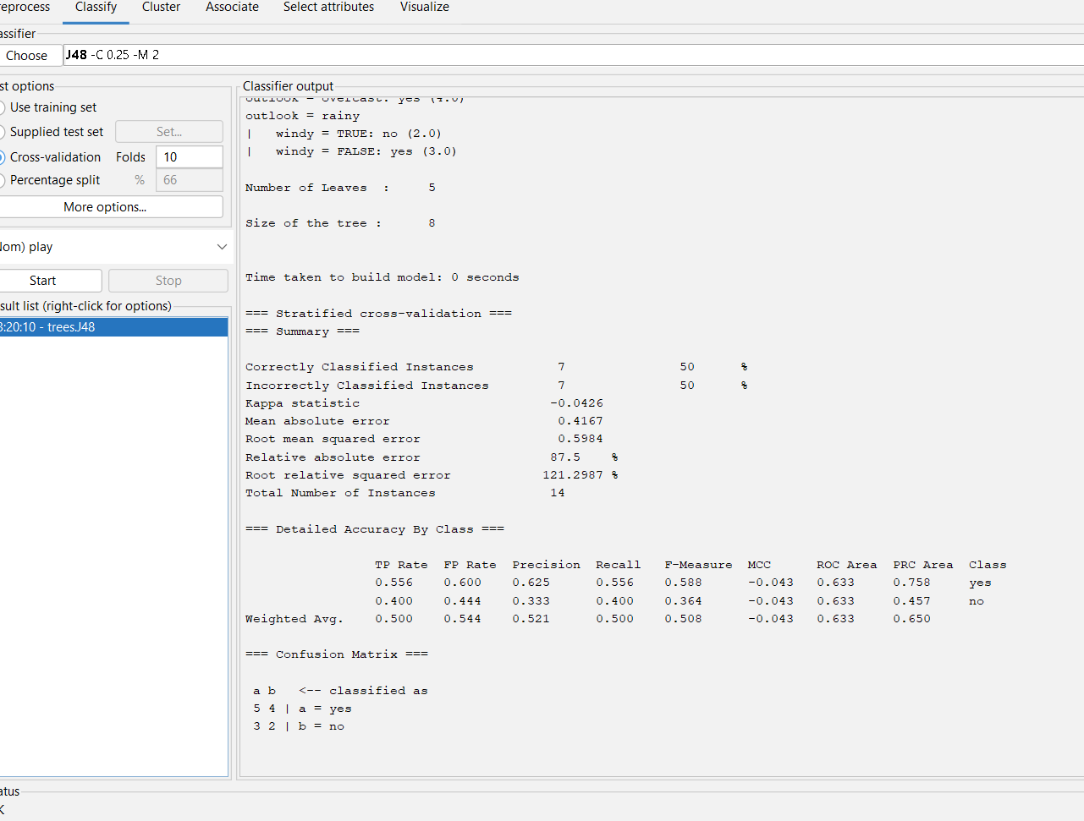

OUTPUT INFO.